ADOPTED – FEBRUARY 23, 2021
AGENDA ITEM NO. 29

Introduced by the Human Services and Finance Committees of the:

INGHAM COUNTY BOARD OF COMMISSIONERS

RESOLUTION TO APPROVE THE APPLICATION FORM, SCORING CRITERIA FOR THE TRAILS AND PARKS MILLAGE, AND DECLARING THAT A SEVENTH ROUND OF APPLICATIONS FOR THE TRAILS AND PARKS MILLAGE FUNDS WILL BE TAKEN BEGINNING MARCH 1, 2021

RESOLUTION #21 – 101

WHEREAS, in March 2020, the electorate renewed a countywide trails and parks millage levy of 50/100
(.50) of one mill to be used for the purpose of creating and maintaining a county system of recreational trails and adjacent parks trail system, which may incorporate trails or parks created by local units of government, including Lansing’s River Trail, and may acquire rights of way to connect and extend existing trails; and

WHEREAS, the Park Commission reviewed and edited the Application and Scoring Criteria forms and has developed the following attachments for approval by the Board of Commissioners; and

WHEREAS, the Application shown in Exhibit A reflects changes outlining that eligible projects must fit the following categories: trail, blueway, boardwalk, bridge, planning & engineering, other project and small grant which includes rehabilitation and new project applications; and

WHEREAS, the Scoring Criteria shown in Exhibit B has been edited to adjust the points received for small community grants up to $300,000.00 for municipalities contributing less than 5% of total county millage revenue collected to date; and

WHEREAS, the applicant is not required to provide match, however, applicants that do contribute match will receive additional points under the Scoring Criteria; and

WHEREAS, the Park Commission recommends that a seventh round of applications will be taken beginning March 1, 2021, and applications are due on July 30, 2021 (Exhibit C).

THEREFORE BE IT RESOLVED, that the Ingham County Board of Commissioners adopts the recommended application edits for Trails and Parks Millage funding (Exhibit A) with the changes outlined above.

BE IT FURTHER RESOLVED, that the Ingham County Board of Commissioners adopts the scoring criteria for use by Park Commission and staff for scoring applications for funding (Exhibit B) with the changes outlined above.

BE IT FURTHER RESOLVED, that a seventh round of applications will be taken beginning March 1, 2021, and applications are due on July 30, 2021 with no required match for the following categories: trail, blueway, boardwalk, bridge, planning & engineering, other project and small grant requests with a cap of $300,000 for municipalities contributing less than 5% of total county millage revenue collected to date, which includes rehabilitation and new project applications.

BE IT FURTHER RESOLVED, that application forms and scoring criteria will be reviewed and approved by the Board of Commissioners prior to the eighth round.

HUMAN SERVICES: Yeas: Tennis, Sebolt, Slaughter, Trubac, Graham, Naeyaert, Maiville
Nays: None Absent: None Approved 02/22/2021

FINANCE: Yeas: Grebner, Tennis, Crenshaw, Polsdofer, Stivers, Schafer, Maiville
Nays: None Absent: None Approved 02/17/2021

EXHIBIT A:
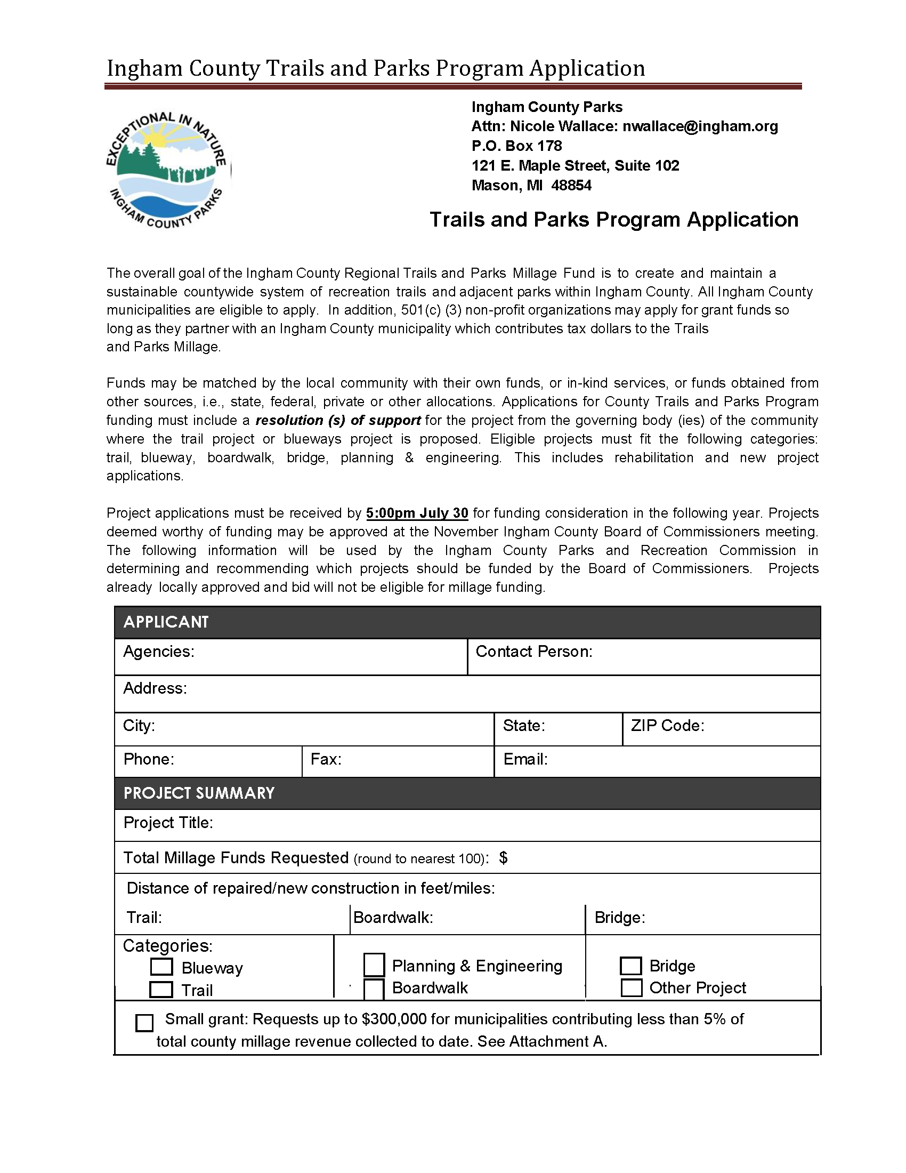
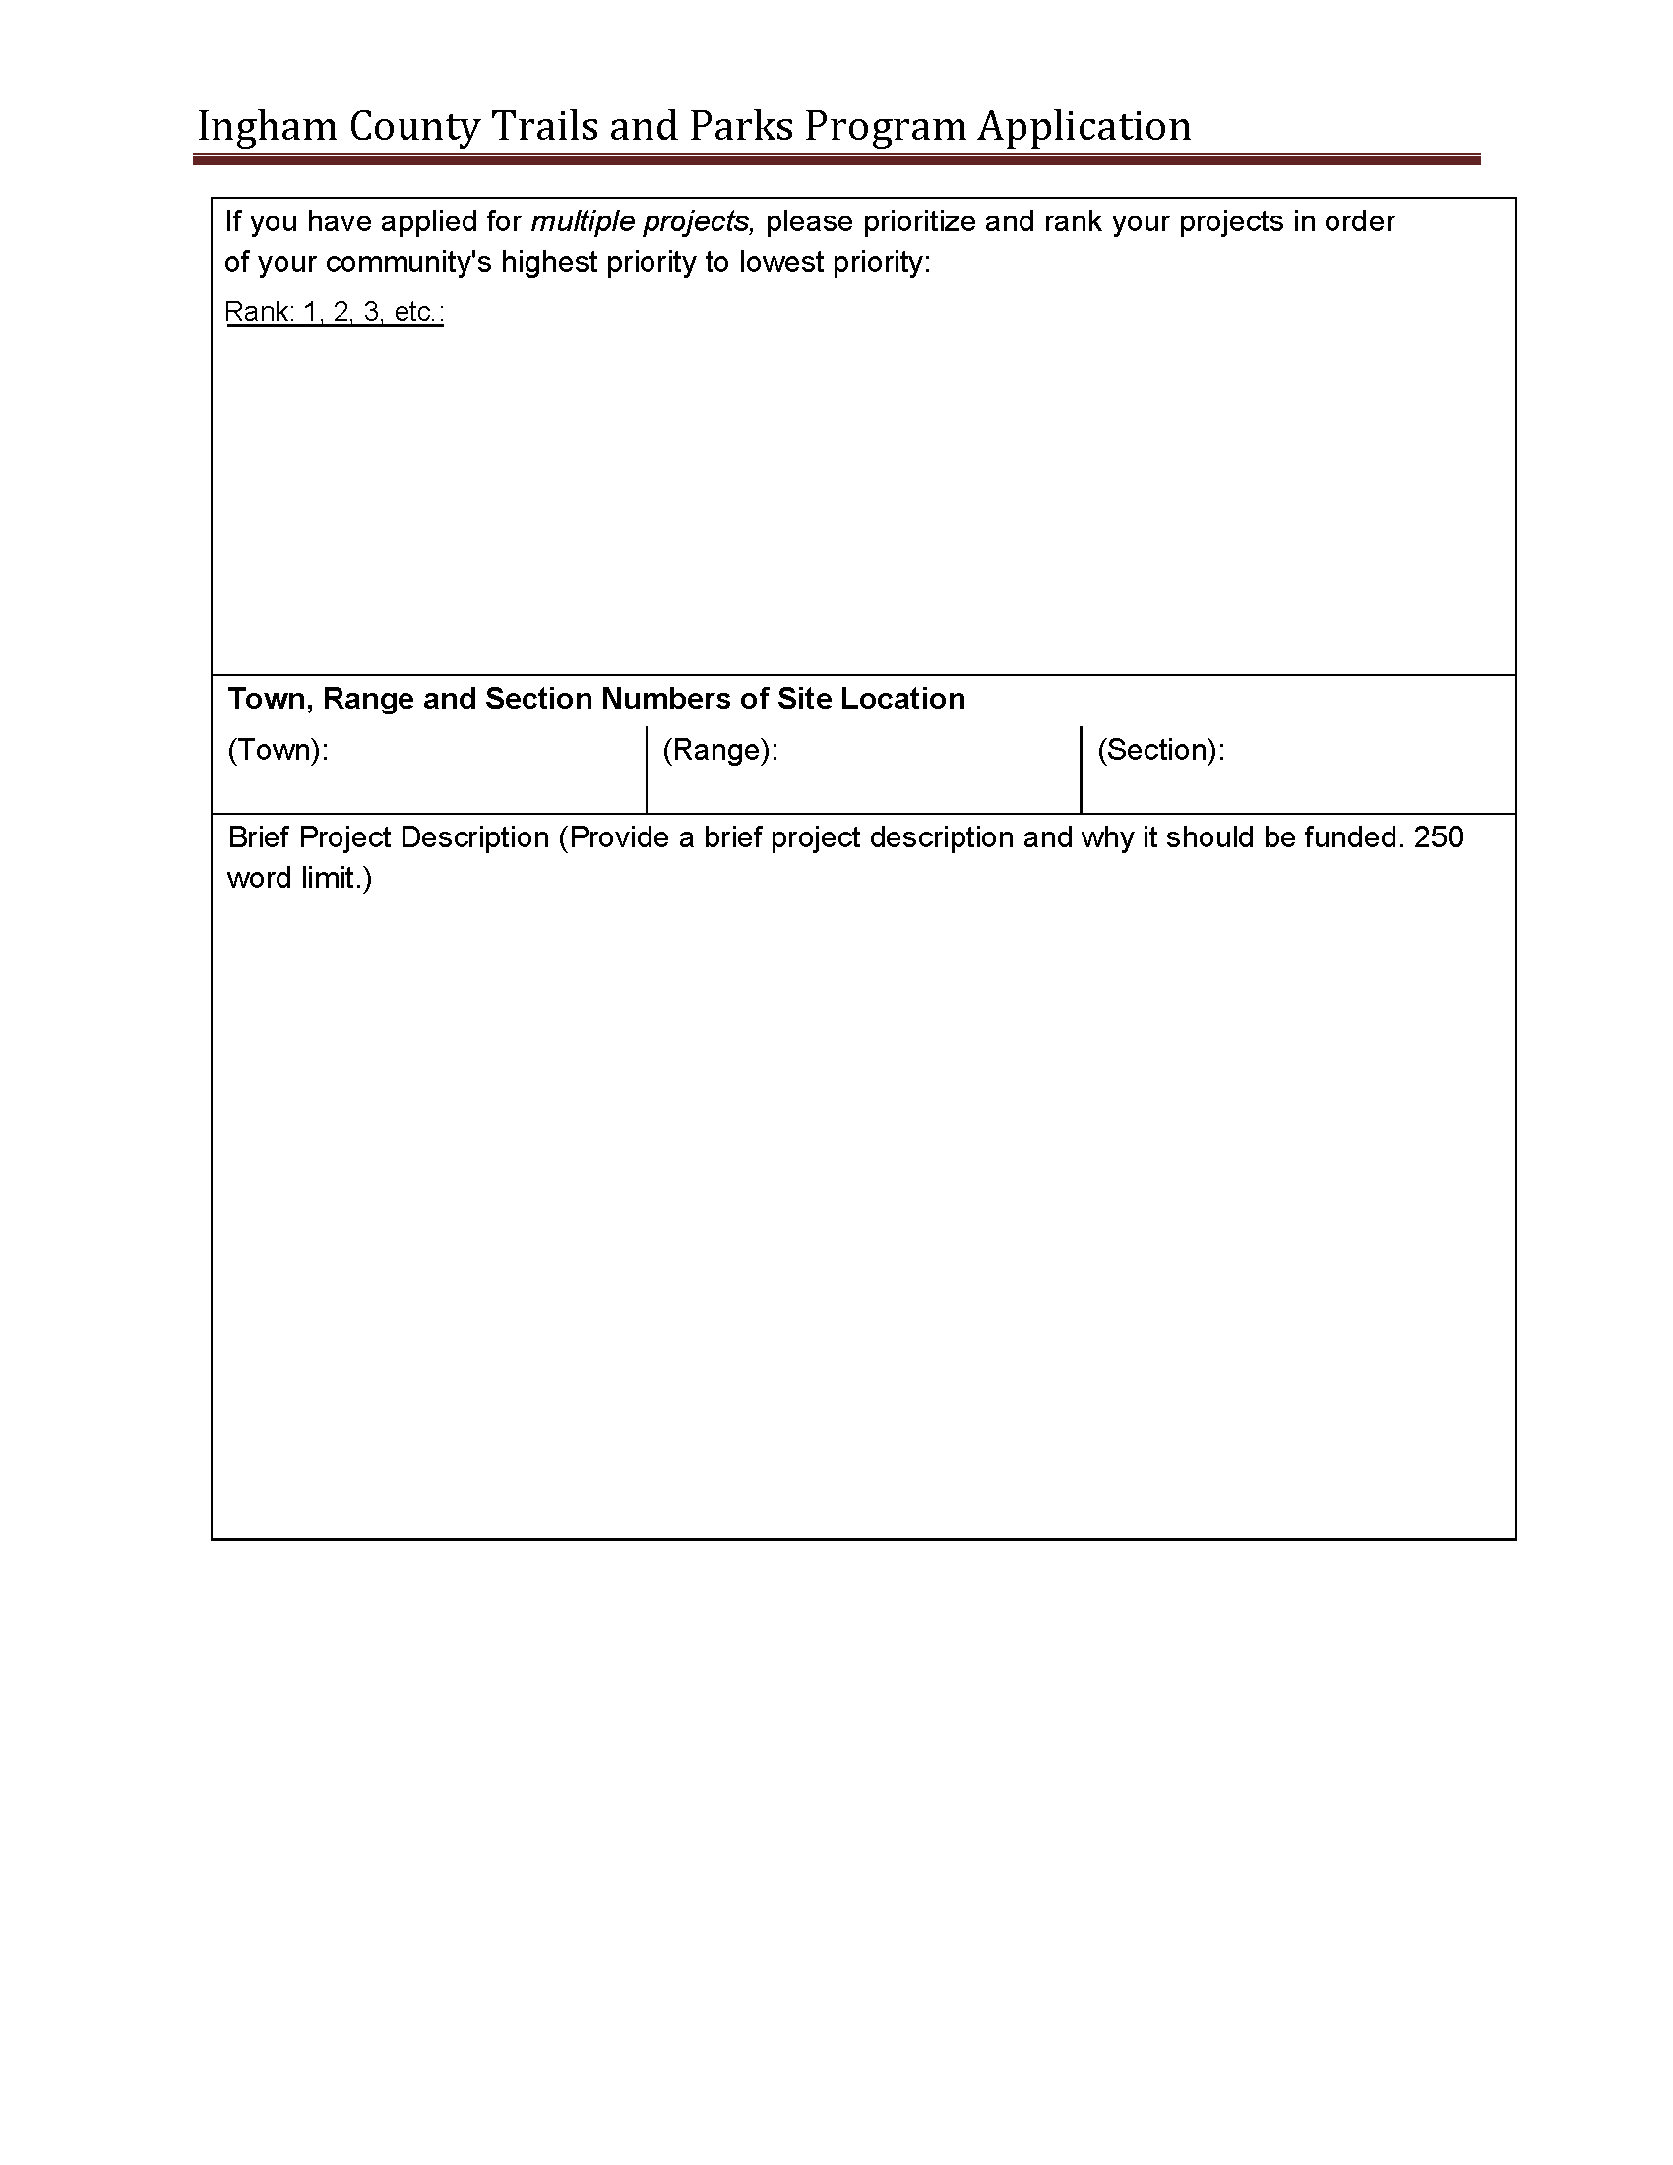
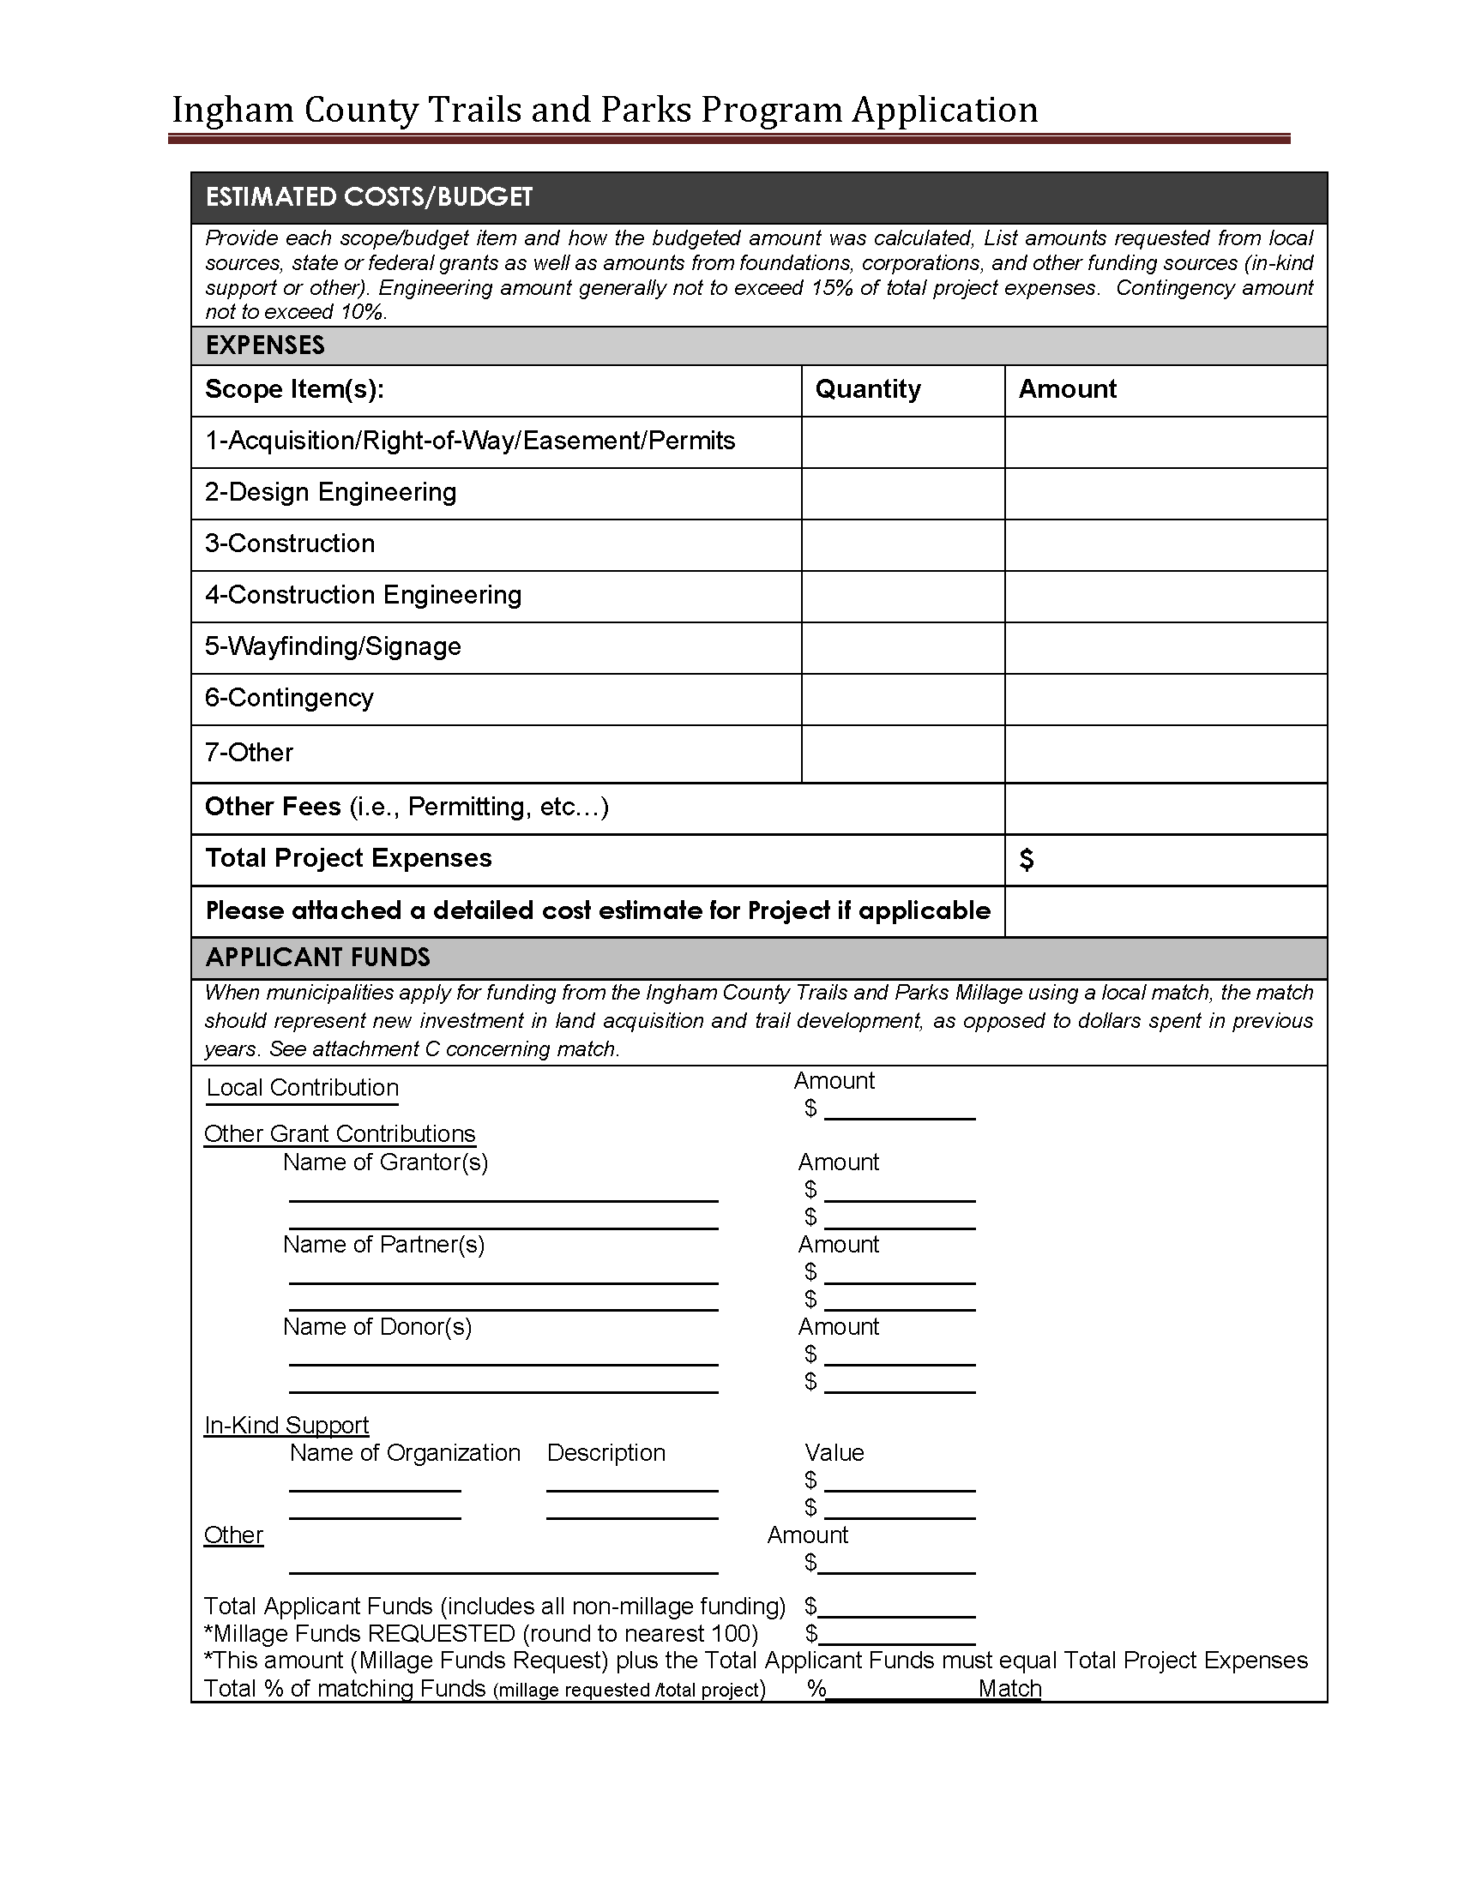
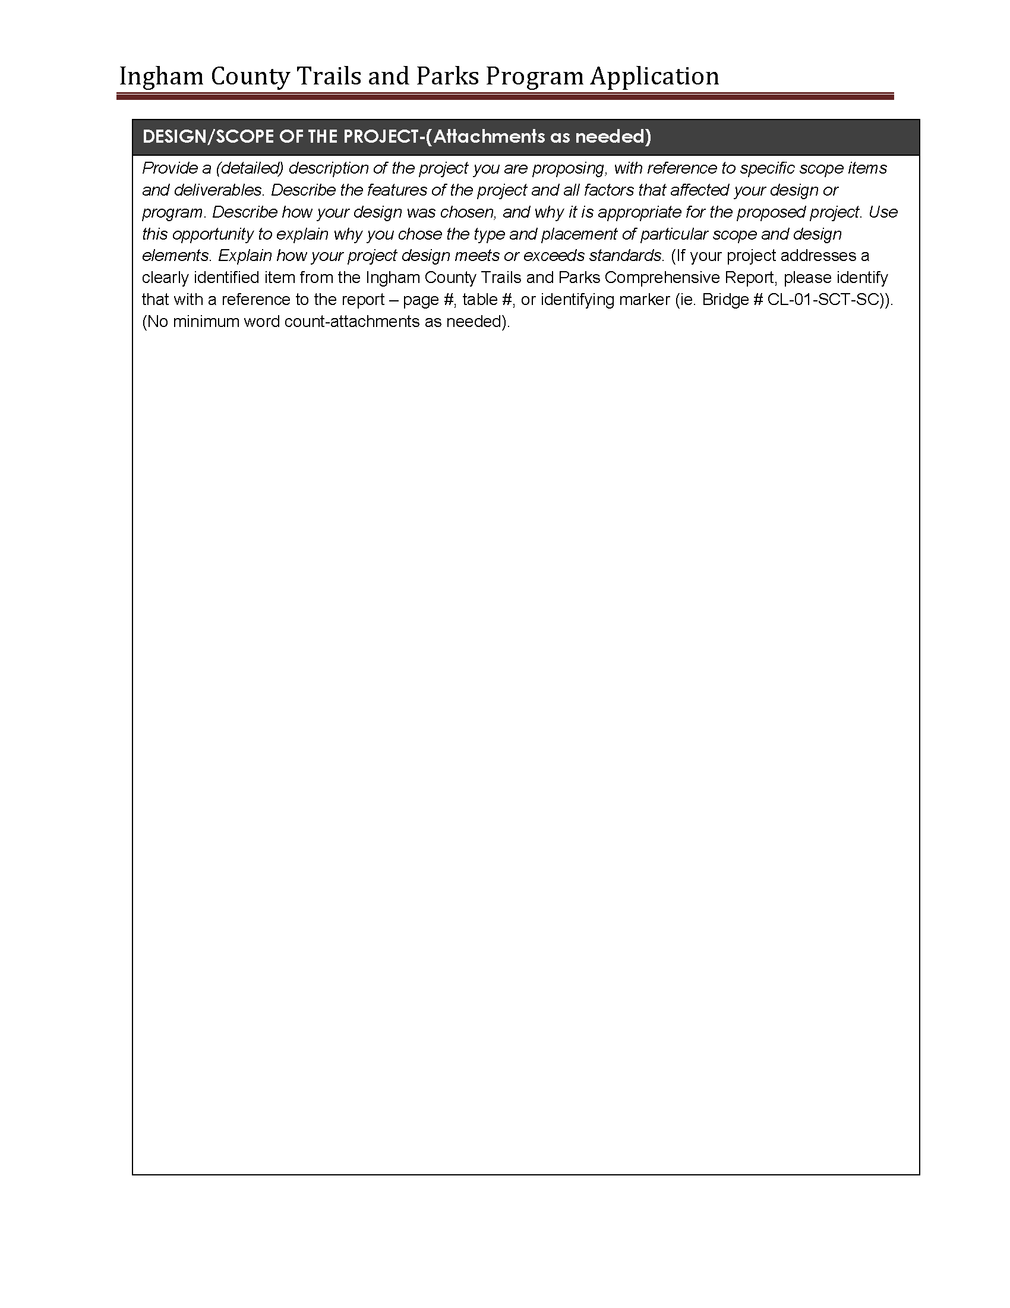
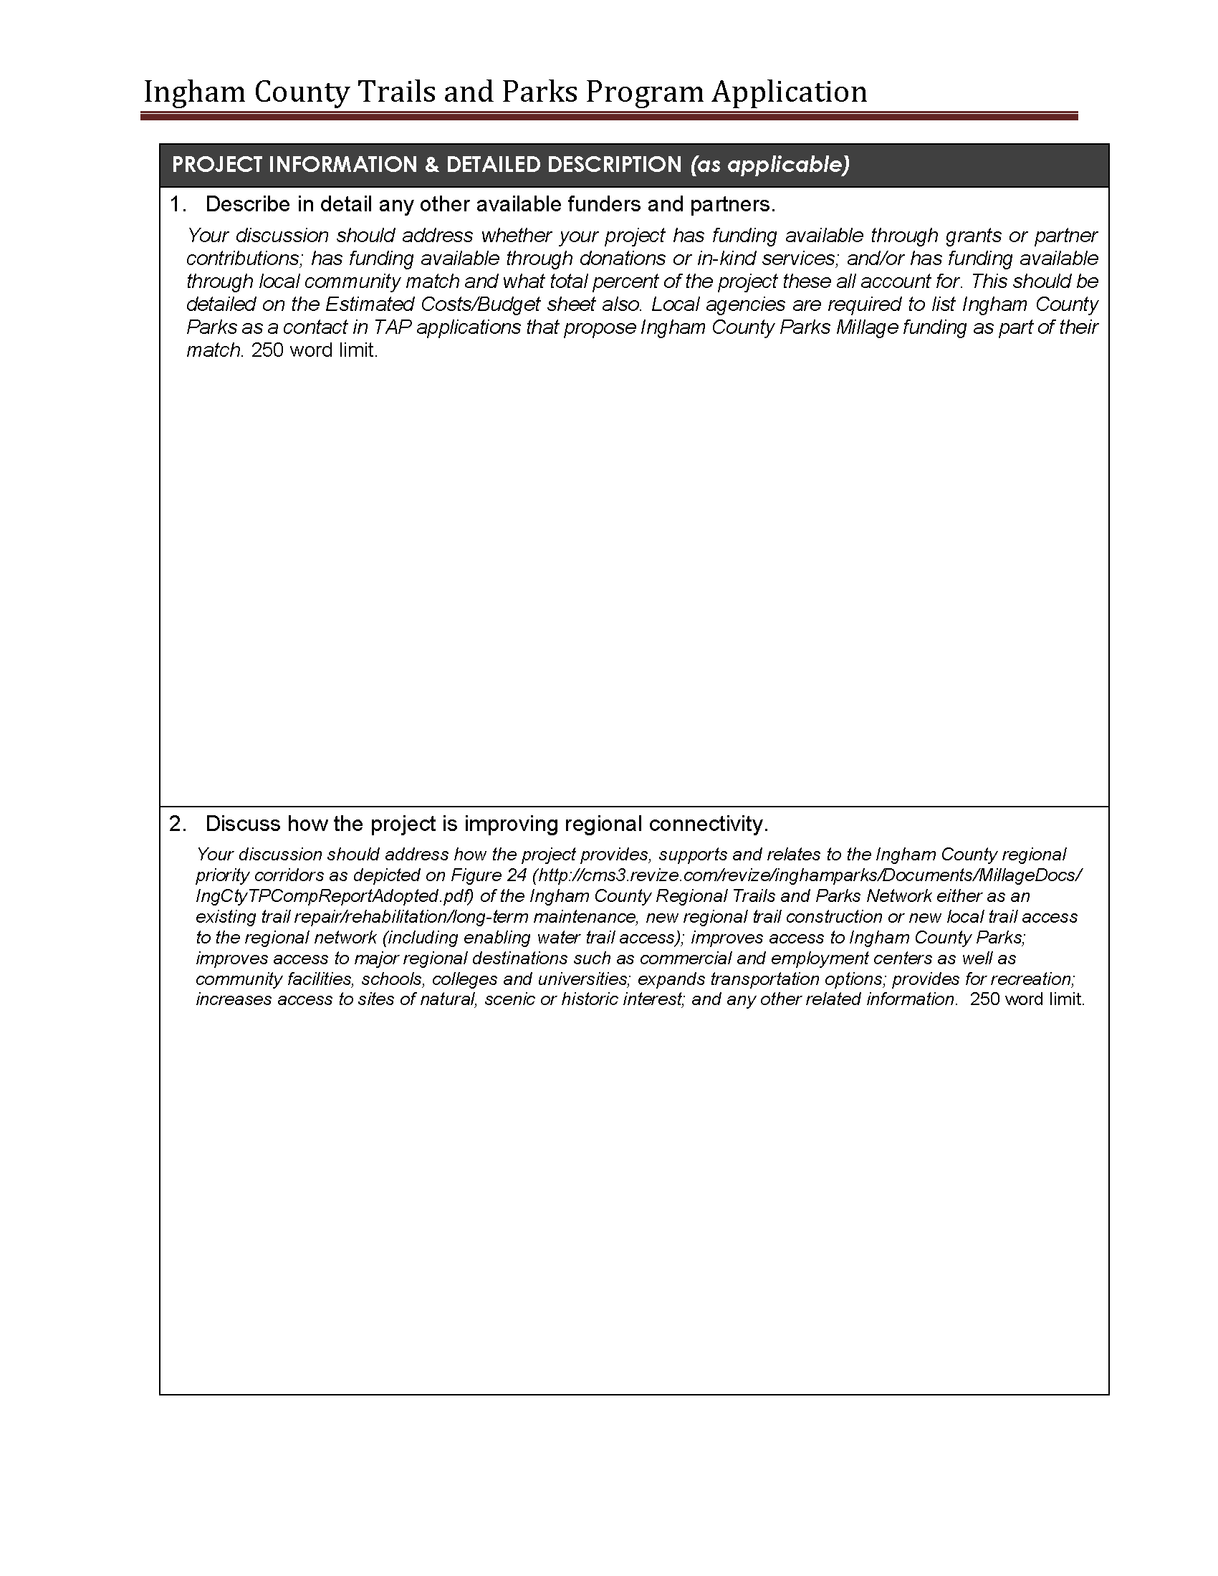
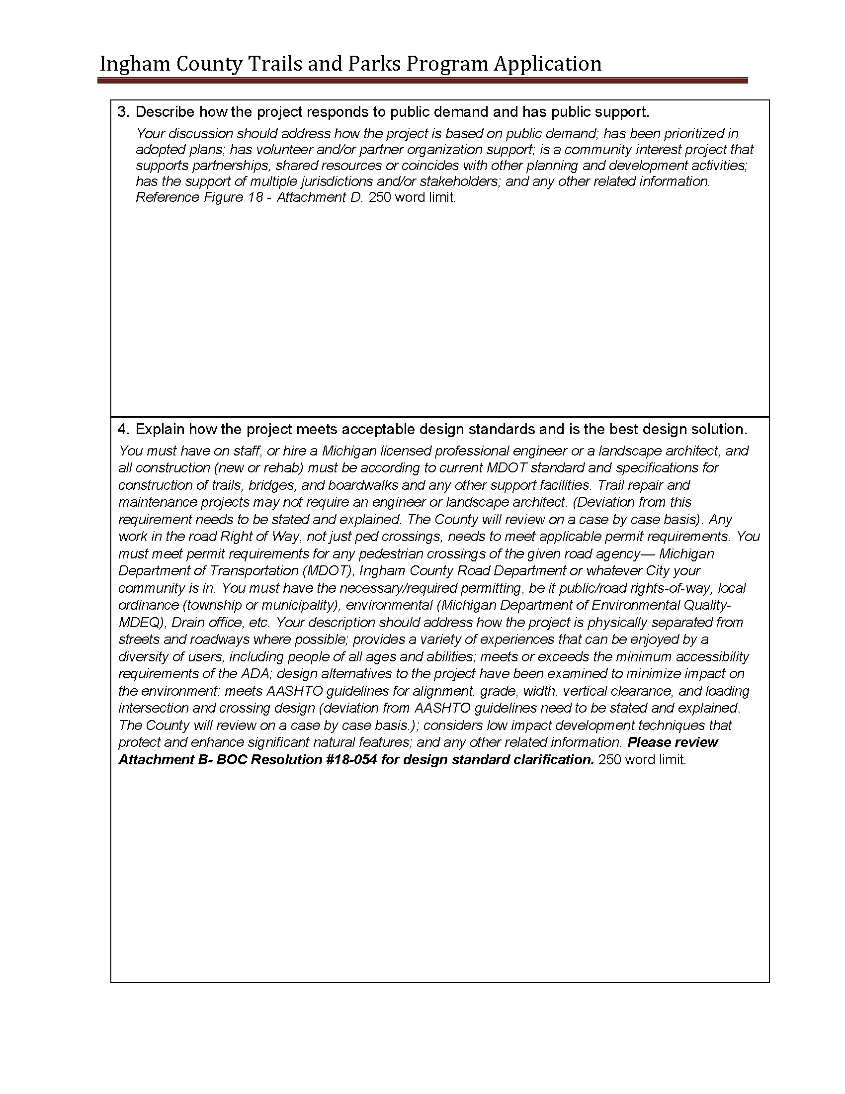
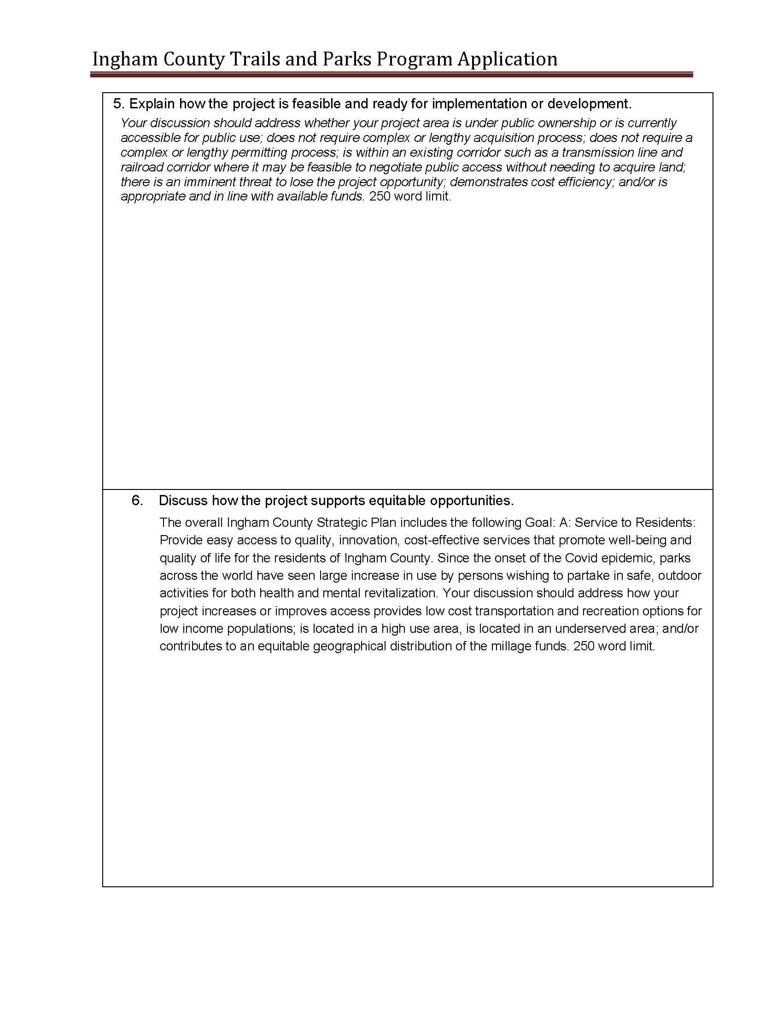
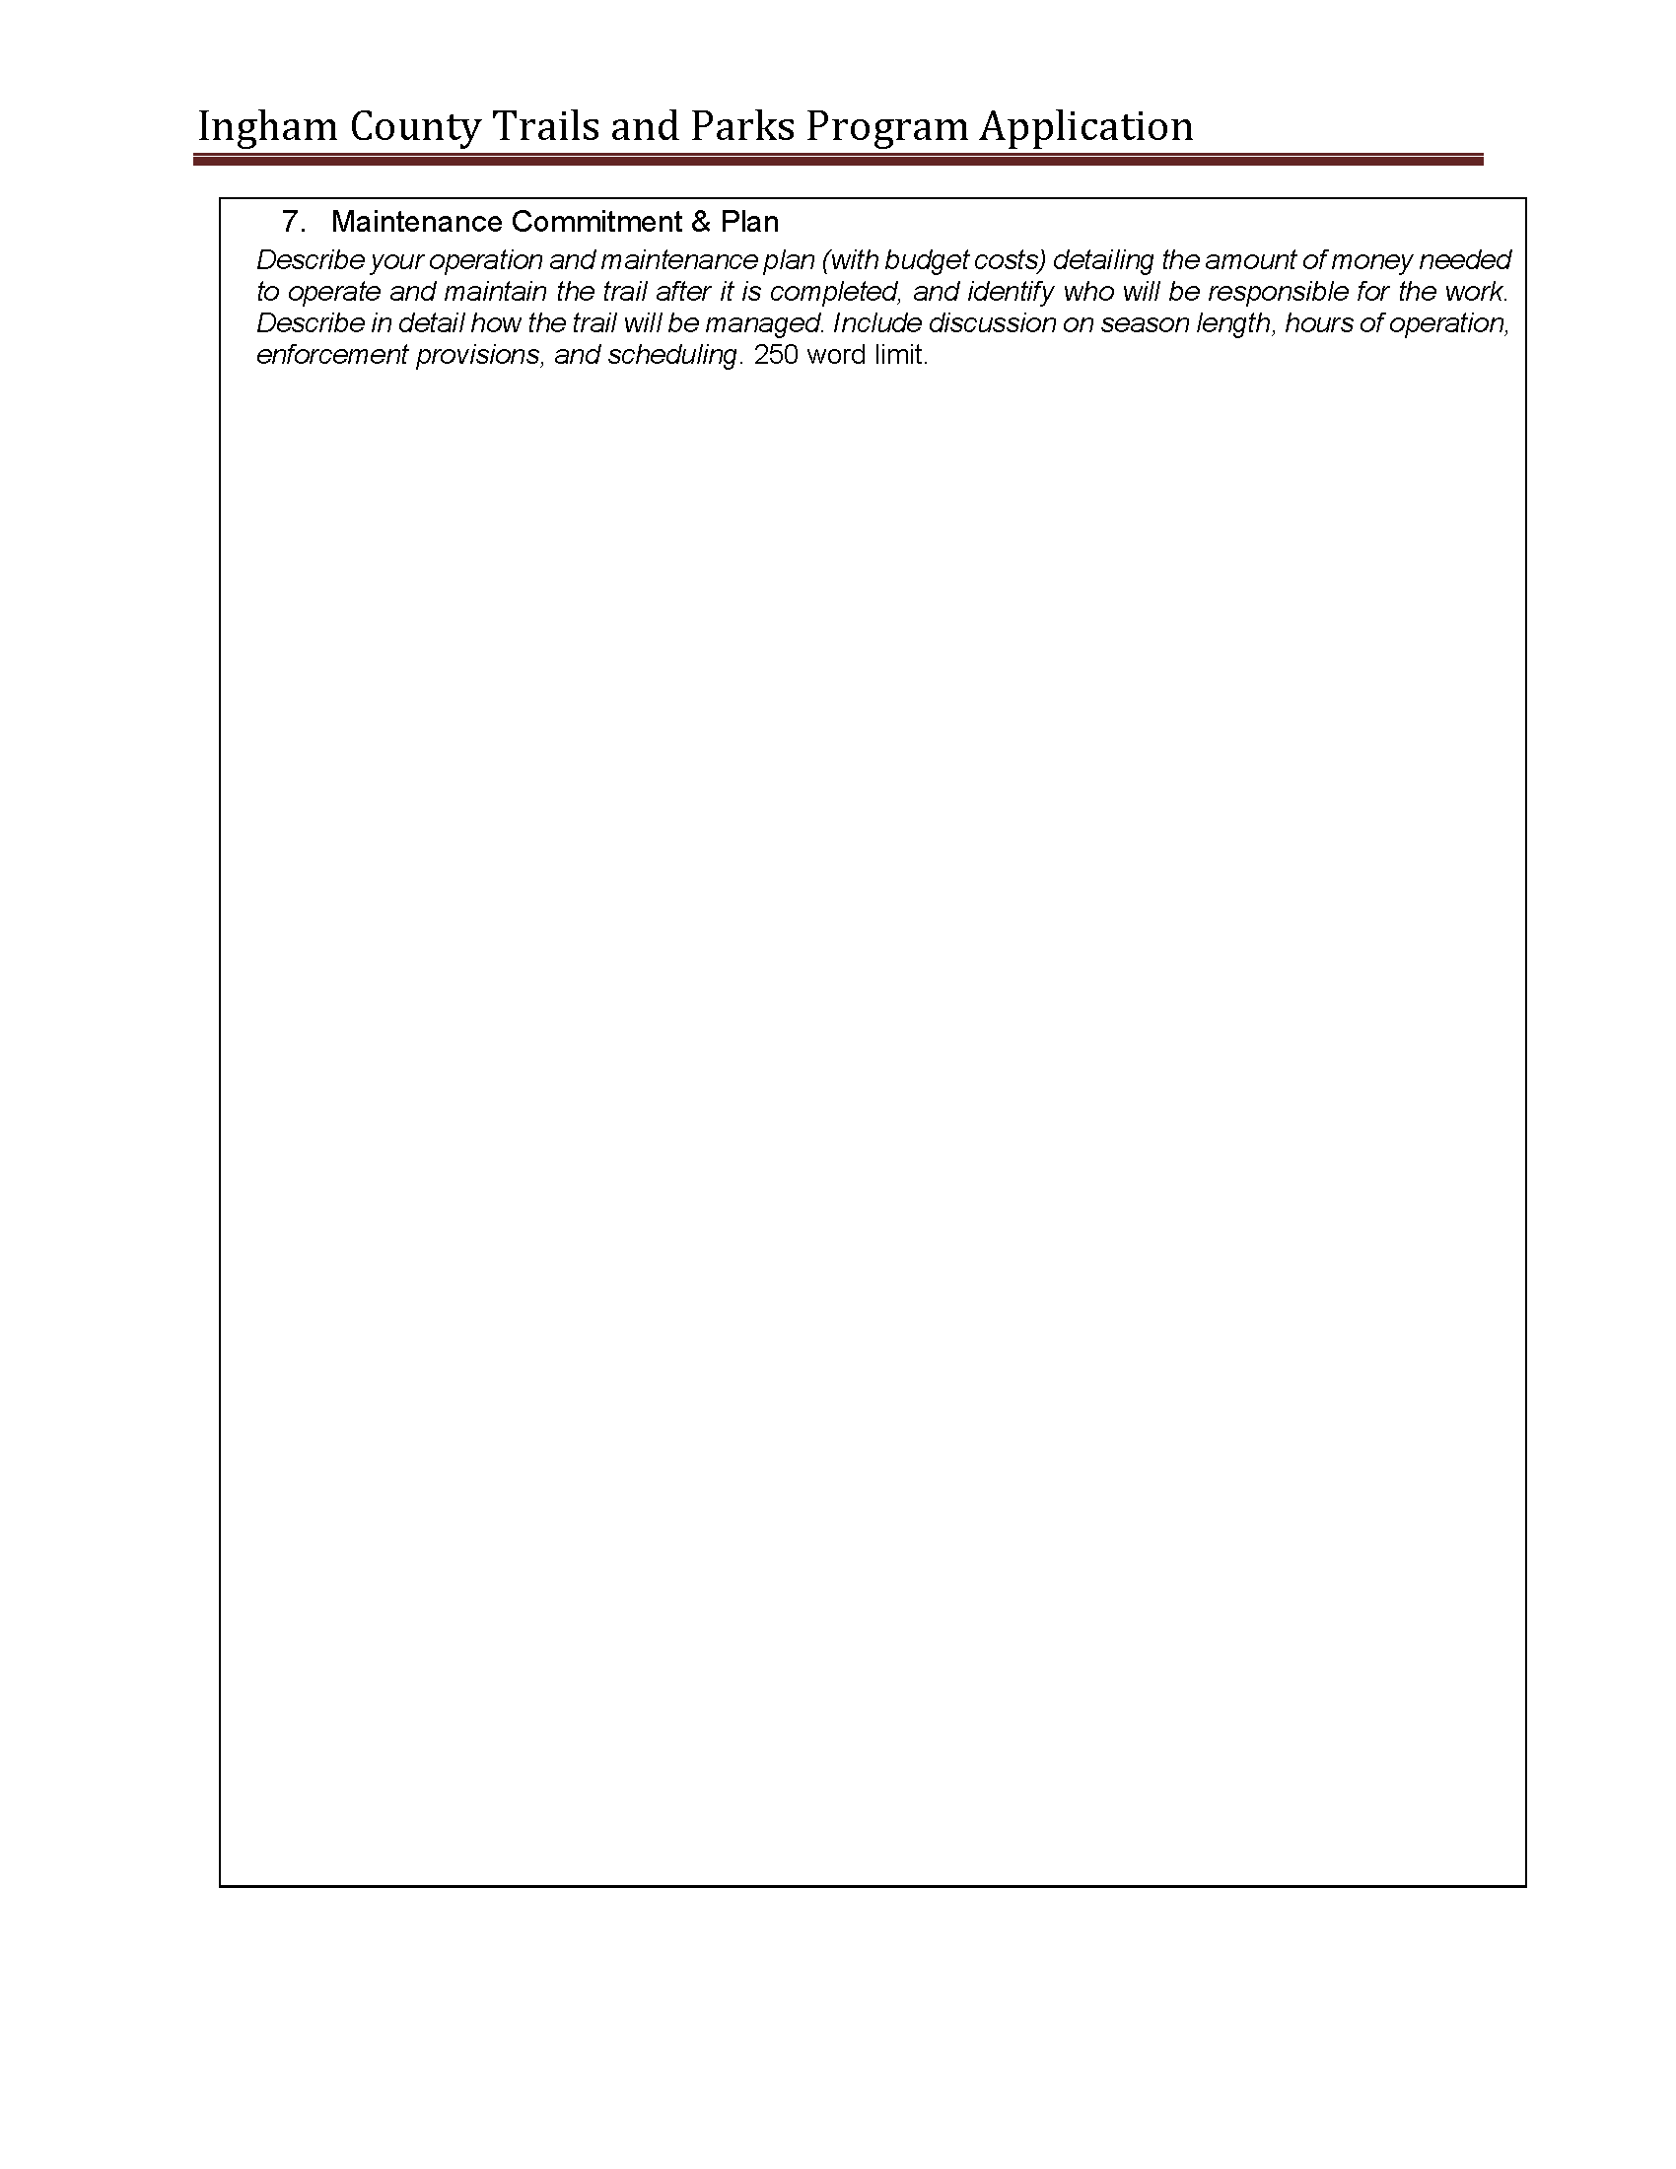
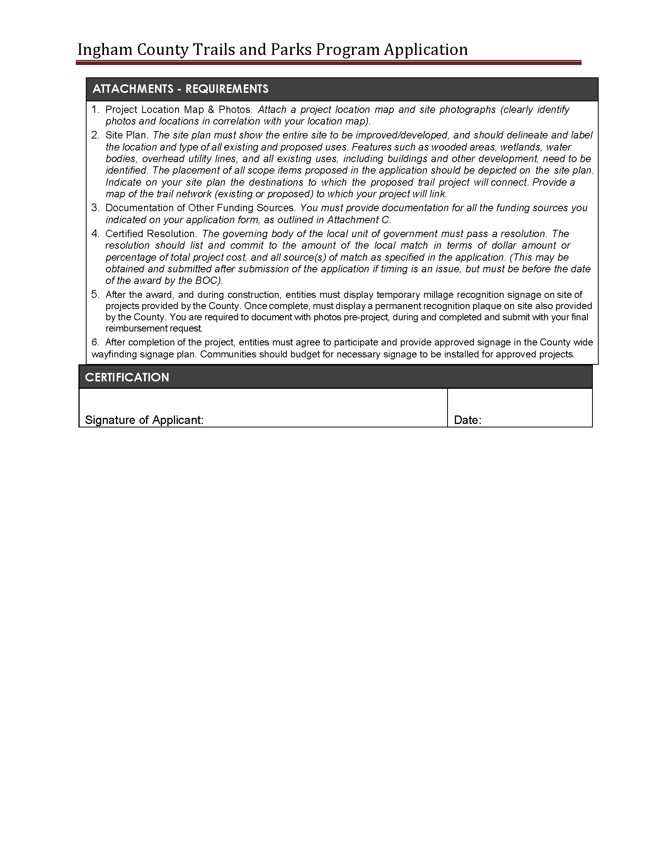
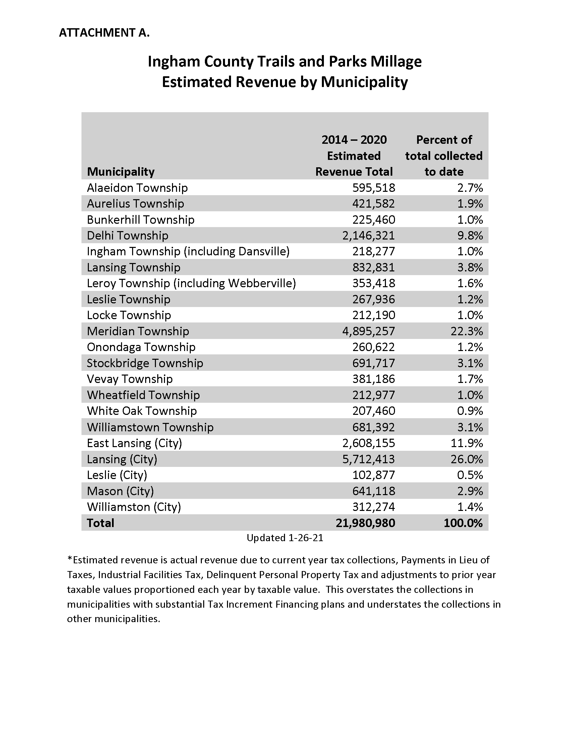
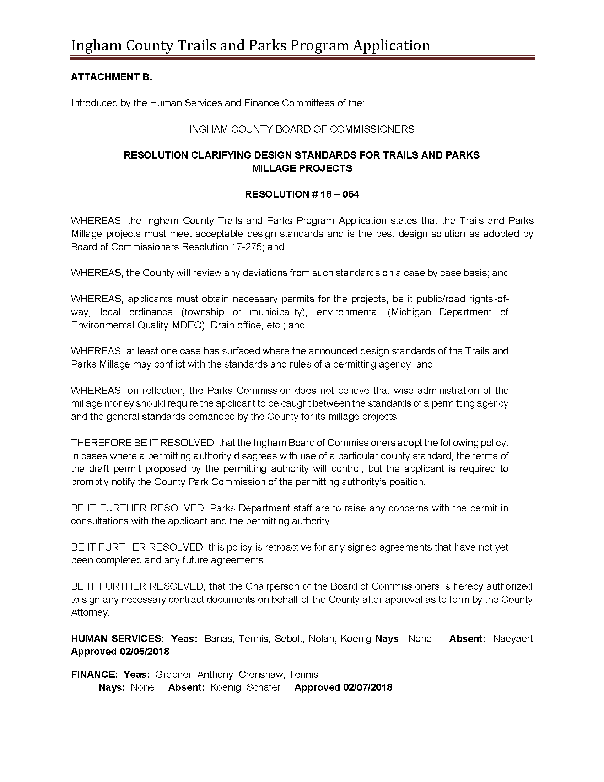
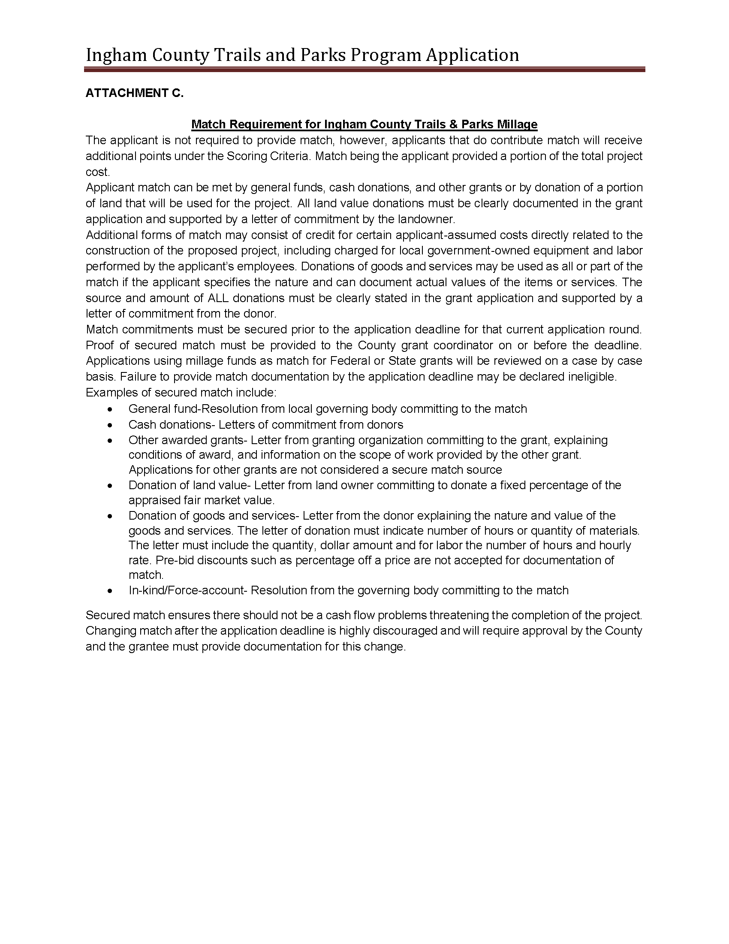
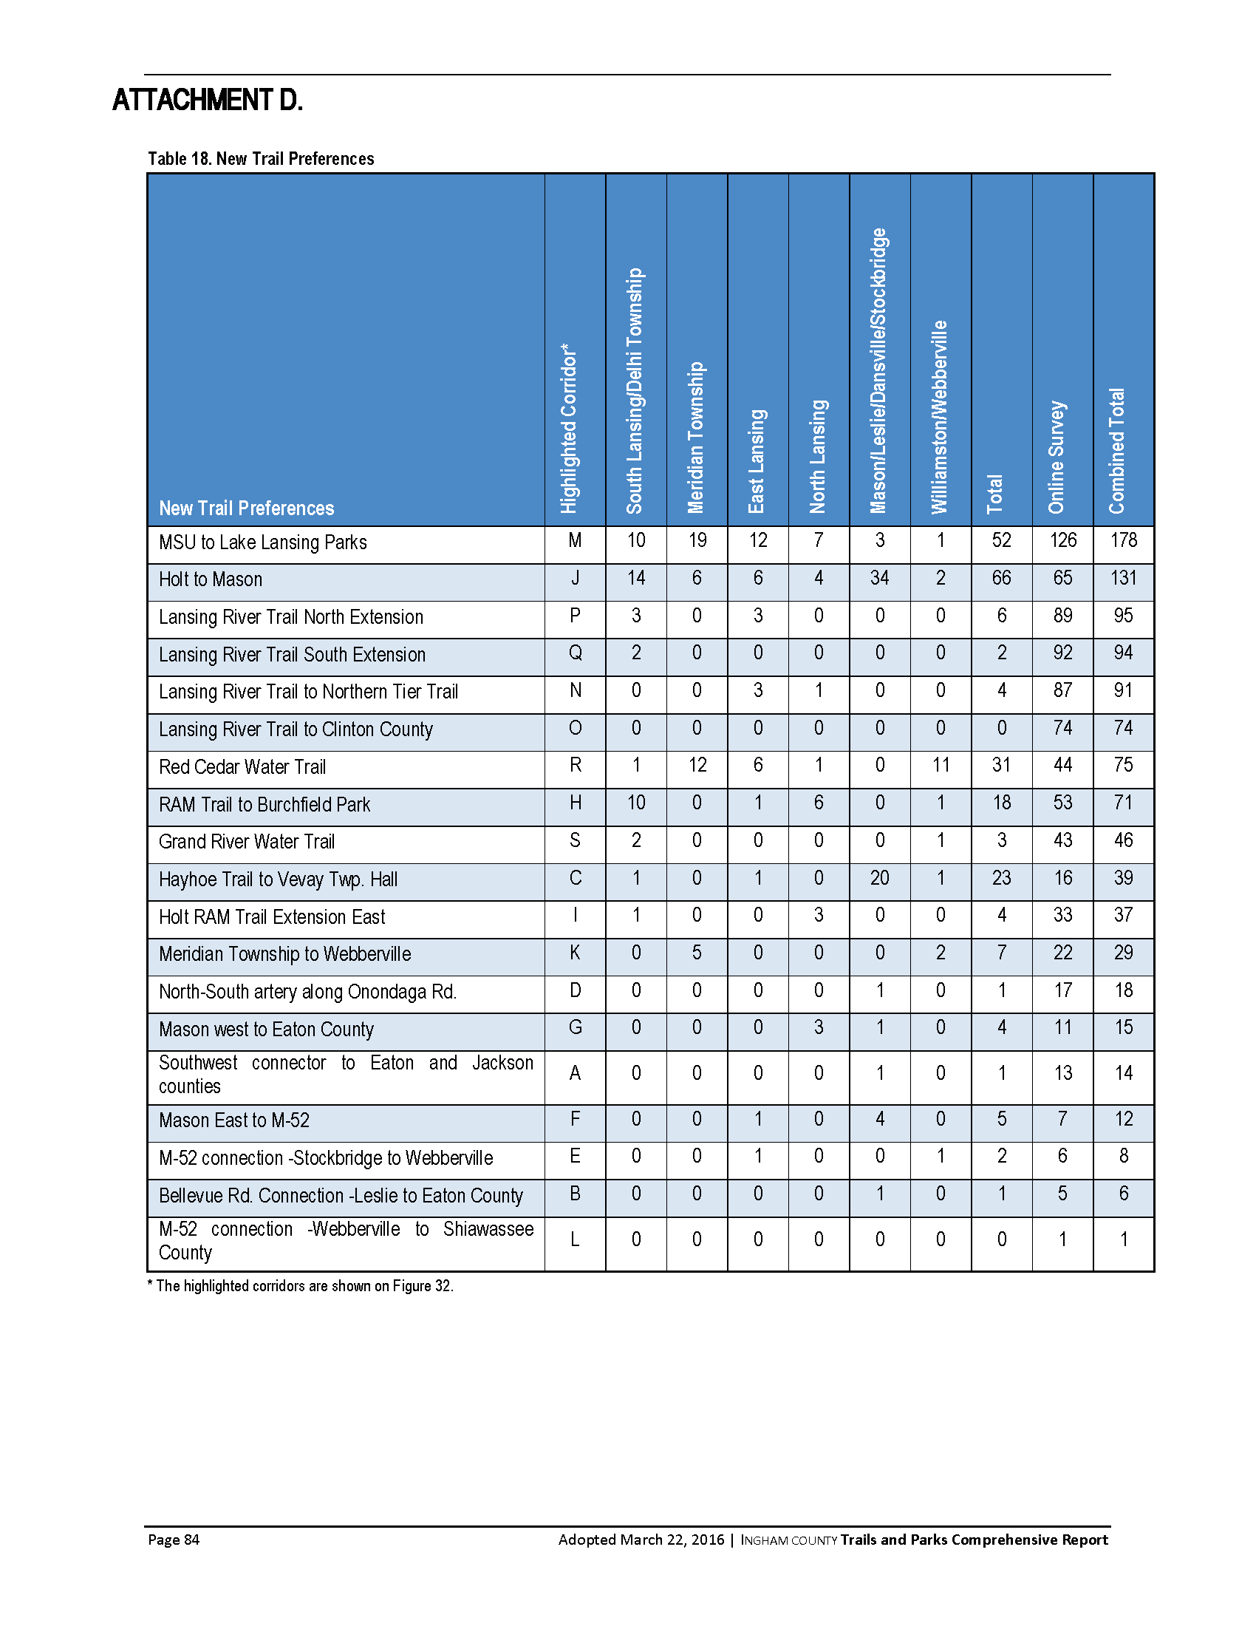

EXHIBIT B:
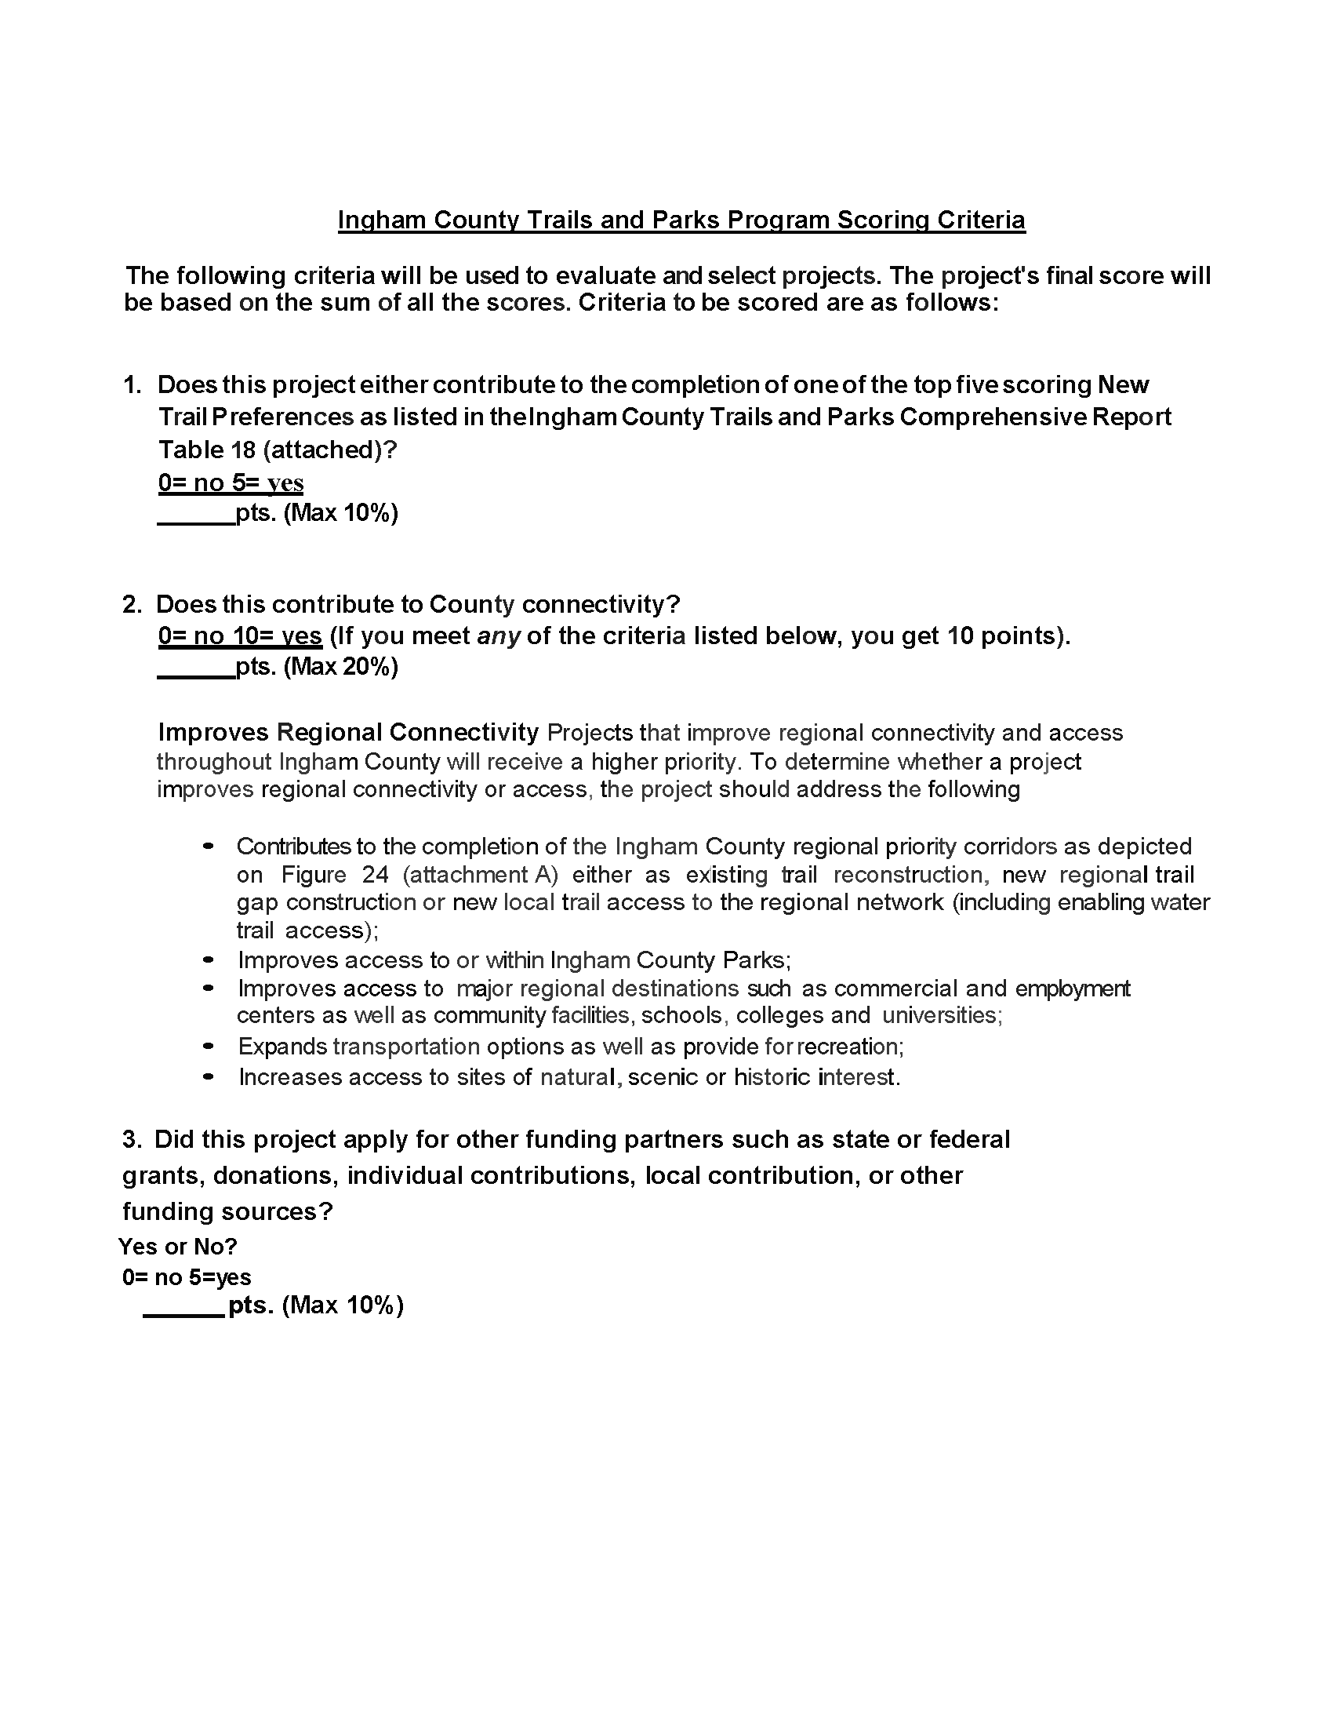
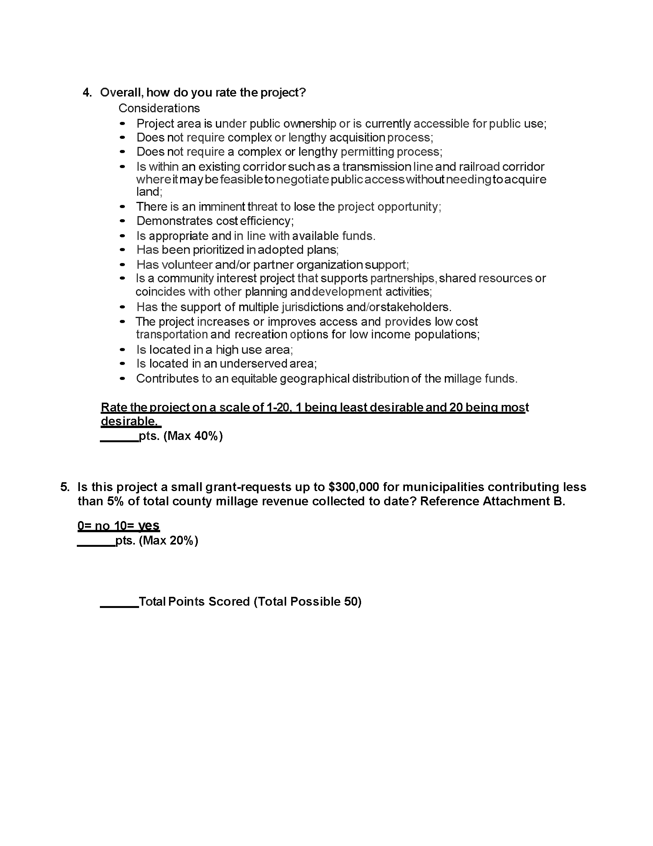
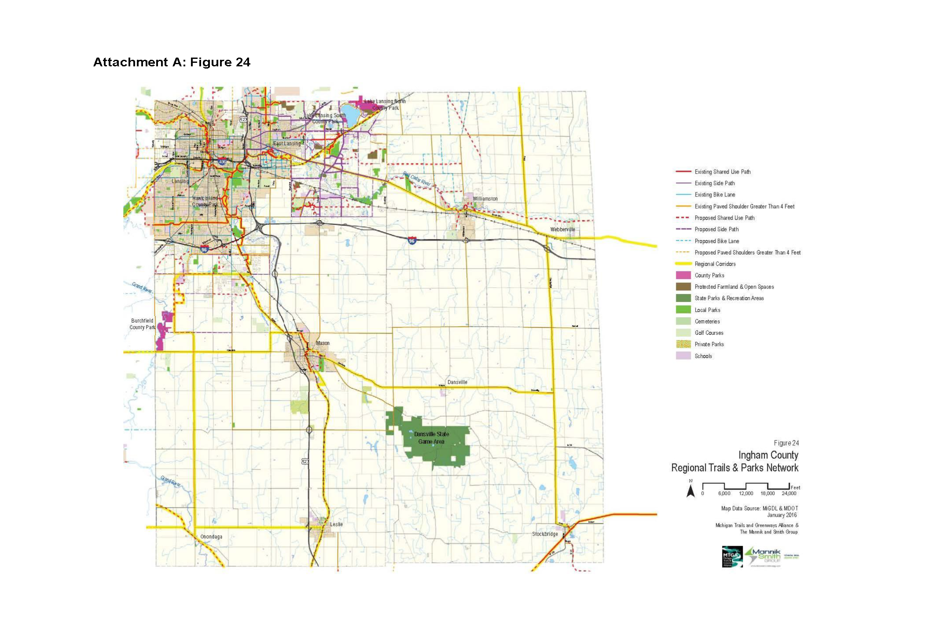
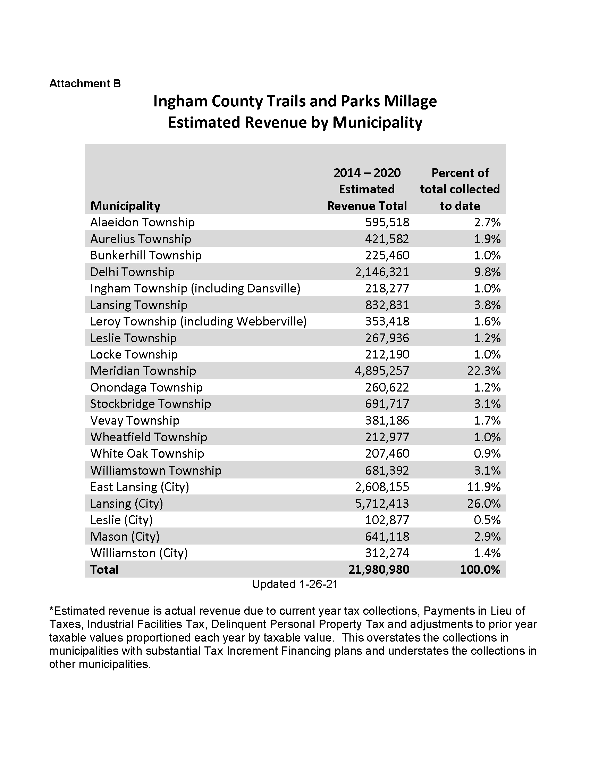

EXHIBIT C:


